For this assignment I would like you guys to create a catalogue using the tables

The outcome should look like this:

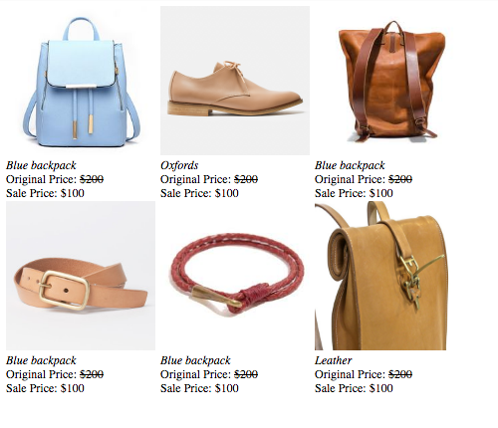

Use this to help you get started:

<table>

<tr>

<td><img src="http://i.ysi.bz/Assets/44/345/M_p0051734544.jpg" height="200" width="200">

<br><i>Blue backpack</i>

<br>Original Price: <del>$200</del>

<br>Sale Price: $100</td>

</tr>

</table>

**PASTE YOUR HTML HERE:**